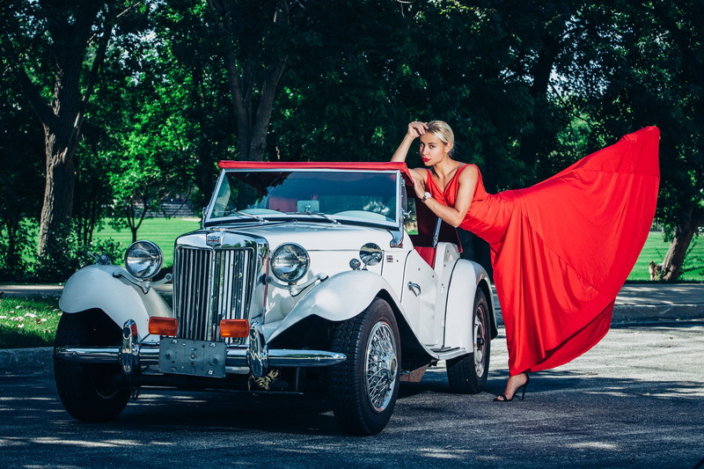
Adriana Kosteckaya, the choreographer
About me:
What kind of person are you?
Too emotional and stubborn in my work. If I see the purpose, my fire does not go out.
What event do you consider a turning point in his life?
Beginning of work with artist Vitaly Kozlovsky! I started working as a solo artist-dancer, before that, I had worked only in a couple, all 5 years I was burning on the stage. Vitaly has made me the fire that never went out. As well as working in the theatre “Black square”, theatre taught me to see easier on everything, and be stronger! Strength is in simplicity!
Are you selfish by your nature? Are you ready to sacrifice your own interests for others?
No, I am not selfish, but I learn to be.
What are you ready to go to achieve your goals?
Ready to sacrifice just a little while. But I can't betray my heart and when I feel unhappy, I come back and go on. Ready to go to any torture, but never betray your soul, everything I have, I reached by myself and no one can tell me that I have a rich daddy or the boyfriend.
Do You consider yourself a wise man? What is your understanding of wisdom?
Yes, I consider myself wiser, but this wisdom has not known through books, but across the street. For me, wisdom is an experience.
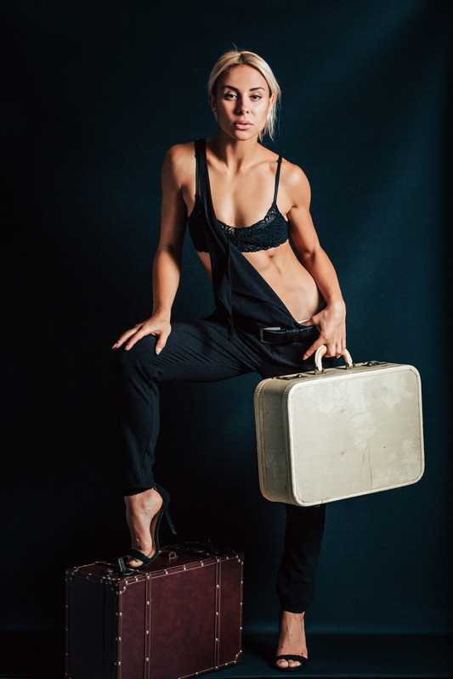
Adriana Kosteckaya, the choreographer
Relationship:
What are you looking for in a man?
At the man, sometimes, I look for myself.
What habits of other people do you put out?
I hate, when a lot of talking and little doing, I don't believe in words.
Is there any place for cheating in a relationship?
Cheating can be physical, but not mental... Sometimes painful, when you do not congratulate with a happy birthday, than to know, that he has another.
What qualities do you appreciate in others?
I appreciate the respect, first of all - the truth. Whatever it was.

Family:
Tell me about your childhood.
I had not had a childhood, and too quickly I had to be an adult, but childhood is a dance hall and a train.
What did you want in the childhood, about what did you dream?
I dreamed, that my parents were proud of me, I wanted, they were happy seeing me on the stage or on TV.
What have you inherited from your parents?
I learned from all by a little: from the dad - the love to sport, hard work. He was a football player and raised me as a boy and my dad taught me to draw. From the mother - the character and a desire not to sit still, everything else is from mine grandmother. I think so, but in general, none of my relatives are an artist.
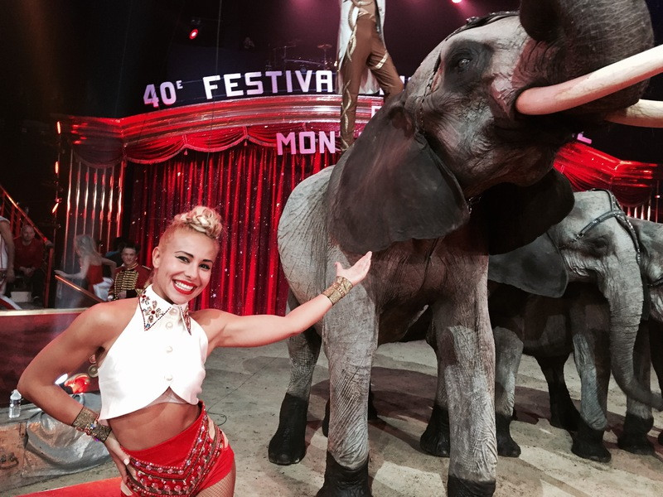
Creativity / Career:
What do you like the most in your job?
I love to go on the stage, this is my house!
What are the main qualities of the choreographer?
The choreographer for me, is a man, who knows, how to convey his emotions without words and through the body, all the other are the athletes.
What should be the dance in your understanding?
Dance is not a lie, it's a truth, because the main thing is true.
Is there any song, that is at least partially describes your life?
In each, even in a bad song, I find a piece of my selves.
What is your biggest achievement in your career?
It is participation in the project “Everybody Dance” on the channel STB.
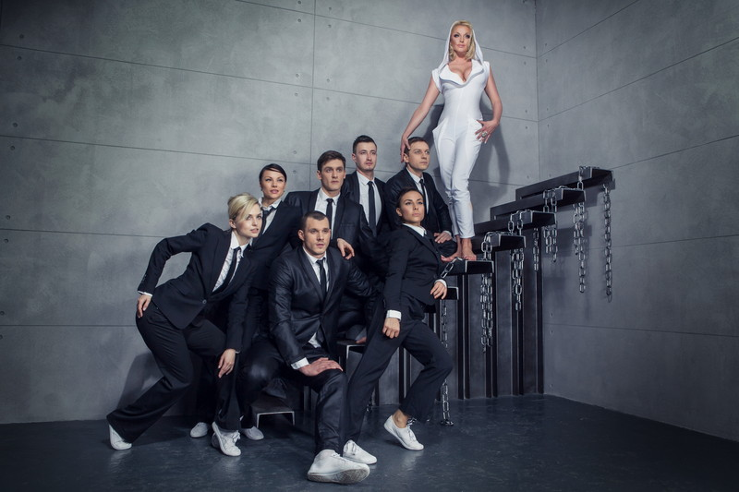
Anastasia Volochkova, Adriana Kostetskaya and her ballet "Every Dance"
General:
What was the most beautiful thing you have ever seen?
The most beautiful was flowering in India, when you touch, it flourishes, taking the hand, it closes, I couldn't believe it! It really was very beautiful.
What do you do, when you can't sleep at night?
I often can't sleep, and especially in America. Sing so, that all the neighbors sometimes knocks and I write all the time - the poems and the thoughts, sometimes I draw.
If someone will write a book about your life, what would be the title?
Angel’s love.

http://geometria.ru/users/3354438/blog/330482

